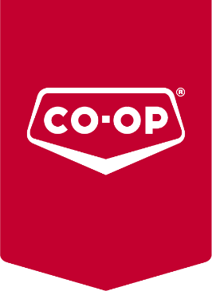

Cornerstone Co-operative
5017 42nd Street St. Paul AB
T0A 3A2 Canada

T 780-645-3351
F 780-645-3270
E: graham.getz@cornerstone.crs
W: www.cornerstonecoop.crs

September 26, 2022

Cornerstone Co-op Phases Out Single Use Plastic Bags
As part of government legislation, Cornerstone Co-op will be preparing to phase out single-use plastic check bags at all their locations this fall. Starting October 24th, plastic bags will no longer be available at the twenty-four Cornerstone Co-op locations.

“We began this journey back in 2019 when we started encouraging reuse by charging 5 cents per plastic grocery bag and donating 3 cents back towards our Bags for Breakfast Program for every reusable bag a member brought and utilized at our food stores,” said Kory Kralkay, Director of Operations. “The idea was that by bridging recycling with our schools breakfast programs, we can help reduce the collective impact on the environment while increasing our impact on students through nutrition.”

Cornerstone Co-op will continue to allocate donations towards their Bags for Breakfast Program but instead of donating 3 cents from each reusable bag used in store by their owners, 10 cents from every reusable bag purchased will be donated back to nutrition programs in our local schools. Since 2017, over $150,000 has been directed to schools for initiatives that establish and enhance breakfast and lunch programs for students.

“Last year, we sold over 1.5 million bags,” said Dan Bojarski, Facilities Manager. “That is a lot of non-biodegradable bags that ended up in a landfill. Removing single use plastics from our checkout stands was always the plan and we have sourced appropriate alternatives and processes to make the transition at all our locations.”

Cornerstone Co-op has food stores located in St. Paul, Elk Point, Vermilion, Wainwright, Mannville and Dewberry. Customers who forget to bring their reusable bags when grocery shopping can purchase a reusable cloth bag from as little as 39 cents. “There will be the opportunity for customers to choose paper bags, but there will be charges,” says Associate Director of Consumer Operation Aaron Knopp. “Paper bags actually have an influential carbon footprint and need to be utilized 43 times to utilize the true value of the material even though the most you’ll get is 5-10.”

Phone and online grocery orders will be delivered by the Cornerstone grocery teams via cardboard boxes or containers. Their teams will also be assisting their regular customers in packing their supplied reusable bags in store.

Jordyn Prior
Marketing & Community Engagement Manager
About Cornerstone Co-op
Cornerstone Co-op services a trading area of 300,000 squared kilometres in rural Eastern Alberta. Built by founders of legacy community Co-ops, Cornerstone makes life better in the spirit of co-operation, by enhancing the quality of life in its eight communities (St. Paul, Elk Point, Mannville, Dewberry, Two Hills, Vermilion, Wainwright and Provost). Our Team Members focus on providing world class Co-op experiences for our 32,000 active owners at 24 locations as a regional Co-op.

